ØØ Explanation :
- We have two digits available at the memory locations D000 H and D001 H in unpacked BCD form. The digit at D000 H is the LSB, whereas digit at D001 H is MSB. To pack the two numbers, means to combine the two numbers.
- To make the digit at D001 H as MSB we rotate it 4 times to the left. i.e. if digit = 09 H, after rotating it by a 4 times it becomes 90 H. Now add the two numbers. Result will be packed BCD. Store the result.
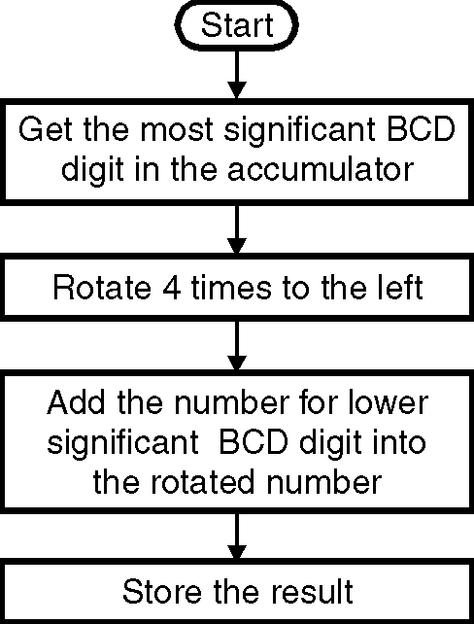
e.g. : D001 H = 09 N
D000 H = 02 H
Result = 92 H
ØØ Algorithm :
Step I : Load the most significant BCD digit in A.
Step II : Rotate MSB 4 times to left.
Step III : Store the result of rotation in register C
Step IV : Load the least significant BCD digit in A.
Step V : Add least significant BCD digit into ; rotated number.
Step VI : Store the result.
Step VII : Stop.
ØØ Flowchart : Refer flowchart 24.
ØØ Program : Flowchart 24
Instruction Comment
LDA D001H ; Get the Most significant BCD digit
RLC ; Rotate the BCD 4 times to left to make it MSB
RLC
RLC
RLC
MOV C, A ; Store the partial result
LDA D000H ; Get the lower BCD digit
ADD C ; Add lower BCD digit
STA D002 ; Store the result
HLT ; Terminate program execution

